%reset  
%matplotlib inline  
import matplotlib.pyplot as plt  
from matplotlib import colors  
  
#IPython is what you are using now to run the notebook  
import IPython  
print ("IPython version: %6.6s (need at least 6.1.0)" % IPython.__version__)  
  
# Numpy is a library for working with Arrays  
import numpy as np  
print ("Numpy version: %6.6s (need at least 1.13.1)" % np.__version__)  
  
# SciPy implements many different numerical algorithms  
import scipy as sp  
print ("SciPy version: %6.6s (need at least 0.19.1)" % sp.__version__)  
  
# Pandas makes working with data tables easier  
import pandas as pd  
print ("Pandas version: %6.6s (need at least 0.20.3)" % pd.__version__)  
  
# SciKit Learn implements several Machine Learning algorithms  
import sklearn  
from sklearn.discriminant_analysis import LinearDiscriminantAnalysis as LDA  
print ("Scikit-Learn version: %6.6s (need at least 0.19.0)" % sklearn.__version__)  
  
from itertools import combinations as cmb  
  
# MNE is a package for processing (EEG) and (MEG) data   
#import mne  
#print ("MNE version: %6.6s (need at least 0.14.1)" % mne.__version__)

Once deleted, variables cannot be recovered. Proceed (y/[n])? y  
  
  
IPython version: 7.8.0 (need at least 6.1.0)  
Numpy version: 1.17.2 (need at least 1.13.1)  
SciPy version: 1.3.1 (need at least 0.19.1)  
Pandas version: 0.25.1 (need at least 0.20.3)  
Scikit-Learn version: 0.22.1 (need at least 0.19.0)

# Colormap  
cmap = colors.LinearSegmentedColormap(  
 'red_blue_classes',  
 {'red': [(0, 1, 1), (1, 0.7, 0.7)],  
 'green': [(0, 0.7, 0.7), (1, 0.7, 0.7)],  
 'blue': [(0, 0.7, 0.7), (1, 1, 1)]})  
plt.cm.register_cmap(cmap=cmap)  
  
# Set font sizes  
SMALL_SIZE = 12  
MEDIUM_SIZE = 14  
BIGGER_SIZE = 16  
plt.rc('font', size=SMALL_SIZE) # controls default text sizes  
plt.rc('axes', titlesize=SMALL_SIZE) # fontsize of the axes title  
plt.rc('axes', labelsize=MEDIUM_SIZE) # fontsize of the x and y labels  
plt.rc('xtick', labelsize=SMALL_SIZE) # fontsize of the tick labels  
plt.rc('ytick', labelsize=SMALL_SIZE) # fontsize of the tick labels  
plt.rc('legend', fontsize=SMALL_SIZE) # legend fontsize  
plt.rc('figure', titlesize=BIGGER_SIZE) # fontsize of the figure title

# import data  
closed_full = np.loadtxt('./Close_hand_5x.csv',delimiter=';',usecols=range(8))  
open_full = np.loadtxt('./Open_hand_5x.csv', delimiter=';',usecols=range(8))  
held_closed = np.loadtxt('./Closed_30sec.csv',delimiter=';',usecols=range(8))  
held_open = np.loadtxt('./Open_30sec.csv', delimiter=';',usecols=range(8))  
  
# create time axes  
closed_t = np.linspace(0,len(closed_full)/200, num=len(closed_full))  
open_t = np.linspace(0,len(open_full)/200, num=len(open_full))  
held_closed_t = np.linspace(0,len(held_closed)/200, num=len(held_closed))  
held_open_t = np.linspace(0,len(held_open)/200, num=len(held_open))

# plot closed-hand data  
fig, ax = plt.subplots(2, 1)  
fig.set_figheight(10)  
fig.set_figwidth(6)  
ax[0].plot(closed_t[:500],closed_full[:500,0], 'm-')  
ax[0].plot(closed_t[:500],closed_full[:500,1], 'r-')  
ax[0].plot(closed_t[:500],closed_full[:500,2], 'g-')  
ax[0].plot(closed_t[:500],closed_full[:500,3], 'b-')  
ax[0].plot(closed_t[:500],closed_full[:500,4], 'c-')  
ax[0].plot(closed_t[:500],closed_full[:500,5], 'y-')  
ax[0].plot(closed_t[:500],closed_full[:500,6], 'k-')  
ax[0].plot(closed_t[:500],closed_full[:500,7], 'pink')  
ax[0].set_title("Closed Hand Raw Data", fontsize=16)  
ax[0].set_xlabel("Time (s)")  
ax[0].set_ylabel("Raw EMG Signal")  
  
# plot open-hand data  
#ax[1].figure(2)  
ax[1].plot(open_t[:500],open_full[:500,0], 'm-')  
ax[1].plot(open_t[:500],open_full[:500,1], 'r-')  
ax[1].plot(open_t[:500],open_full[:500,2], 'g-')  
ax[1].plot(open_t[:500],open_full[:500,3], 'b-')  
ax[1].plot(open_t[:500],open_full[:500,4], 'c-')  
ax[1].plot(open_t[:500],open_full[:500,5], 'y-')  
ax[1].plot(open_t[:500],open_full[:500,6], 'k-')  
ax[1].plot(open_t[:500],open_full[:500,7], 'pink')  
ax[1].set_title("Open Hand Raw Data", fontsize=16)  
ax[1].set_xlabel("Time(s)")  
ax[1].set_ylabel("Raw EMG Signal")   
fig.tight_layout()  
fig.savefig("Open-Closed Raw Data.pdf",)  
fig.show()

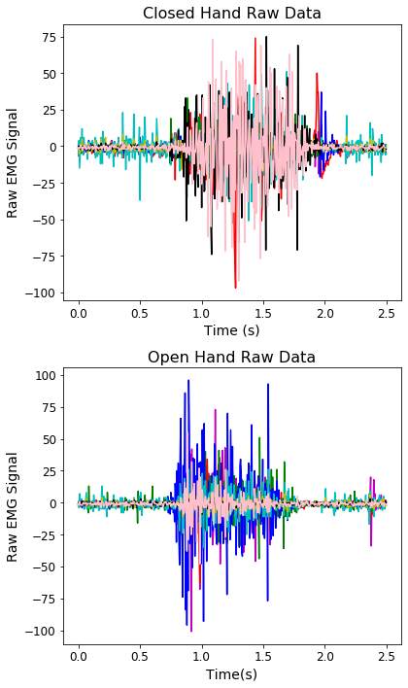

png

# Calculates RMS's of 250ms chunks (for all channels)  
def rms(data):  
 output = np.zeros((8,120))  
 for i in range(8):  
 for j in range(120):  
 low = j * 50  
 high = low + 50  
 output[i,j] = np.sqrt(np.mean(data[low:high,i]**2))  
 return output

# Perform calculation  
closed_rms = rms(held_closed)  
open_rms = rms(held_open)

def lda_plt(cha, chb, class0, class1, fig):  
 # Reformat data for LDA classifier  
 closed_zipped = np.dstack((class0[cha,:], class0[chb,:]))  
 open_zipped = np.dstack((class1[cha,:], class1[chb,:]))  
 data = np.concatenate((closed_zipped, open_zipped), axis=1)[0]  
 classes = np.concatenate((np.zeros(120), np.ones(120)))  
   
 # Perform LDA  
 lda = LDA()  
 lda.fit(data, classes)  
  
 # Plot points  
 plt.figure(fig)  
 plt.scatter(class0[cha,:],class0[chb,:], c='red')  
 plt.scatter(class1[cha,:],class1[chb,:],c='blue')  
  
 #plt.title("Closed vs. Open Hand \nLDA Decision Boundary",fontsize=16)  
 plt.xlabel("Channel "+str(cha)+" RMS")  
 plt.ylabel("Channel "+str(chb)+" RMS")  
  
 # Plot class 0 and 1 areas  
 nx, ny = 200, 100  
 x_min, x_max = plt.xlim()  
 y_min, y_max = plt.ylim()  
 xx, yy = np.meshgrid(np.linspace(x_min, x_max, nx),  
 np.linspace(y_min, y_max, ny))  
 Z = lda.predict_proba(np.c_[xx.ravel(), yy.ravel()])  
 Z = Z[:, 1].reshape(xx.shape)  
 plt.pcolormesh(xx, yy, Z, cmap='red_blue_classes',  
 norm=colors.Normalize(0., 1.), zorder=0)  
 plt.contour(xx, yy, Z, [0.5], linewidths=2., colors='white')  
 plt.savefig("2-Class LDA 0v3.pdf")  
  
  
lda_plt(5,7,closed_rms,open_rms, 1)  
lda_plt(0,3,closed_rms,open_rms, 2)

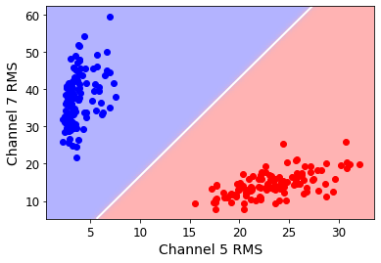

png

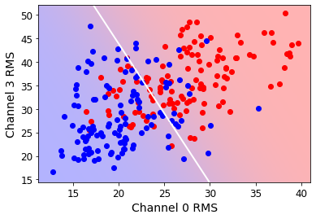

png

def lda_eval(cha, chb, class0, class1):  
 # Reformat data for LDA classifier  
 closed_zipped = np.dstack((class0[cha,:], class0[chb,:], np.zeros(120)))  
 open_zipped = np.dstack((class1[cha,:], class1[chb,:], np.ones(120)))  
 data = np.concatenate((closed_zipped, open_zipped), axis=1)[0]  
 np.random.shuffle(data)  
 classes = data[:,2]  
 data = data[:,:2]  
   
 # Separate training data  
 t_data = data[:int(len(data)*0.25)]  
 t_classes = classes[:int(len(classes)*0.25)]  
   
 # Separate validation data  
 v_data = data[int(len(data)*0.25):]  
 v_classes = classes[int(len(classes)*0.25):]  
   
 # Perform LDA  
 lda = LDA()  
 lda.fit(t_data, t_classes)  
   
 pred = lda.predict(v_data)  
 num_correct = 0  
 for i,p in enumerate(pred):  
 if v_classes[i] == p:  
 num_correct += 1  
 pos_rate = num_correct/len(v_classes)  
 return pos_rate  
   
lda_eval(0,3,closed_rms,open_rms)

0.7944444444444444

# Get all permutations of feature combinations  
combs = list(cmb(np.arange(8),2))  
  
# Evaluate each obtained combination   
results = np.zeros((len(combs),3))  
for i,(cha,chb) in enumerate(combs):   
 tpr = lda_eval(cha, chb, closed_rms, open_rms)  
 results[i,0] = cha  
 results[i,1] = chb  
 results[i,2] = tpr  
  
print(results)

[[0. 1. 0.92222222]  
 [0. 2. 0.98333333]  
 [0. 3. 0.76666667]  
 [0. 4. 0.93888889]  
 [0. 5. 1. ]  
 [0. 6. 1. ]  
 [0. 7. 1. ]  
 [1. 2. 0.93888889]  
 [1. 3. 0.94444444]  
 [1. 4. 1. ]  
 [1. 5. 1. ]  
 [1. 6. 1. ]  
 [1. 7. 0.97777778]  
 [2. 3. 0.99444444]  
 [2. 4. 1. ]  
 [2. 5. 1. ]  
 [2. 6. 1. ]  
 [2. 7. 0.99444444]  
 [3. 4. 0.97222222]  
 [3. 5. 1. ]  
 [3. 6. 0.99444444]  
 [3. 7. 1. ]  
 [4. 5. 1. ]  
 [4. 6. 0.99444444]  
 [4. 7. 1. ]  
 [5. 6. 1. ]  
 [5. 7. 1. ]  
 [6. 7. 1. ]]

print(np.average(results[:,2]))  
print(np.std(results[:,2]))

0.9793650793650794  
0.04659615664471649